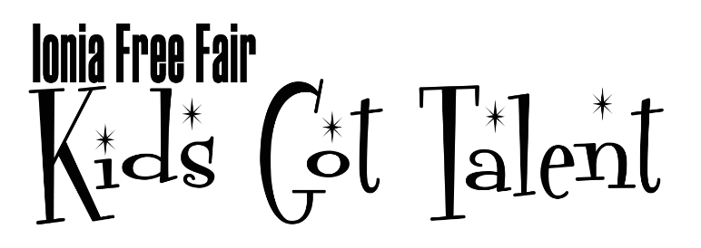
July 18, 2021 3:00pm-5:00pm
Ages 17 years old & younger

PARTICIPANT NAME: ________________________T-shirt size: Youth or Adult
(please circle) XS S M L XL
________________________________________________________

GROUP NAME: ______________________

PARTICIPANT NAME: _______________________ T-shirt size: Youth or Adult
(please circle) XS S M L XL

PARTICIPANT NAME: _______________________ T-shirt size: Youth or Adult
(please circle) XS S M L XL

PARTICIPANT NAME: ________________________T-shirt size: Youth or Adult (please circle) XS S M L XL

DESCRIBE YOUR TALENT
Singing _____ Dancing _____ Comedy _____ Drama _____ Live Band _____

Do you need microphones? _______ How many? ________

Background tracks will be streamed onto one computer for the performance.
Name of your song: _______________________________
Phone #: ___________________________ (Best # to call with questions!)

**The staff of Kids Got Talent reserves the right to not allow certain music or acts to be performed on stage if inappropriate or dangerous. We may have to shorten songs just to give everyone a chance to perform.**

I hereby give permission for my child to perform at the "Ionia Free Fair Kids Got Talent" event.
PARENT/GUARDIAN NAME: _________________________________________
EMAIL:________________________ DO YOU HAVE FACEBOOK? YES OR NO
SIGNED: __________________________DATE: ________________________

ENTRY FORMS: Email a copy to ioniakidsgottalent@gmail.com. Visit the Ionia Free Fair Kids Got Talent Facebook page to ask specific event questions and get information.
Deadline for Entries July 1, 2021

