Ionia County
Rabbit Market
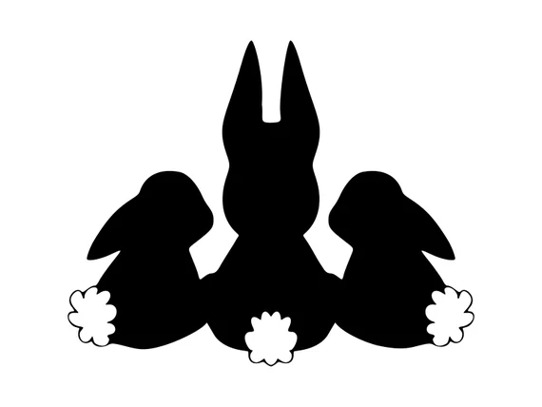
Record Book

Name: ________________________________________________

4-H Club: _____________________________________________

4-H Leader: ____________________________________________

Age (as of 1/1): __________________

Years in Rabbit Project: _________________

Litter Information

Doe
Date Bred:
Buck used:
Date Kindled
Number of Kits:
Live Kits

Doe
Date Bred:
Buck used:
Date kindled
Number of Kits:
Live Kits
Doe
Date Bred:
Buck used:
Date kindled
Number of Kits:
Live Kits
Doe
Date Bred:
Buck used:
Date kindled
Number of Kits:
Live Kits

Market Pedigree

Breed__________  Date of birth  _____________  Name_______  Ear #________  Color________ | Sire  Name_______  Ear #________  Color________ | Grand Sire  Name_______  Ear #________  Color________ | G.G. Sire  Name_______  Ear #________  Color________
G.G. Dam
Name_______
Ear #________
Color________
 |  | Grand Dam  Name_______  Ear #________  Color________ | G.G. Sire  Name_______  Ear #________  Color________
G.G. Dam
Name_______
Ear #________
Color________
 | Dam  Name_______  Ear #________  Color________ | Grand Sire  Name_______  Ear #________  Color________ | G.G. Sire  Name_______  Ear #________  Color________
G.G. Dam
Name_______
Ear #________
Color________
 |  | Grand Dam  Name_______  Ear #________  Color________ | G.G. Sire  Name_______  Ear #________  Color________
G.G. Dam
Name_______
Ear #________
Color________

Market Weight Tracking

Rabbit ear #_______
Weight at 3 weeks
Weight at 4 weeks
Weight at 5 weeks
Weight at 6 weeks
Weight at 7 weeks
Weight at 8 weeks
Weight at 9 weeks
Weight at 10 weeks

Rabbit ear #_______
Weight at 3 weeks
Weight at 4 weeks
Weight at 5 weeks
Weight at 6 weeks
Weight at 7 weeks
Weight at 8 weeks
Weight at 9 weeks
Weight at 10 weeks

Rabbit ear #_______
Weight at 3 weeks
Weight at 4 weeks
Weight at 5 weeks
Weight at 6 weeks
Weight at 7 weeks
Weight at 8 weeks
Weight at 9 weeks
Weight at 10 weeks

Rabbit ear #_______
Weight at 3 weeks
Weight at 4 weeks
Weight at 5 weeks
Weight at 6 weeks
Weight at 7 weeks
Weight at 8 weeks
Weight at 9 weeks
Weight at 10 weeks

Make copies of this page if you are tracking more rabbits.

Expenses

Item | Price

Total expenses $

Attach feed tag from the food you are feeding your market project.
Marketing your market project is very important.
You must deliver at least 5 invitations to potential buyers for the small animal auction. Please attach a copy of your invitation for your buyers and list at least 5 buyers that the letters were sent to on this page.
* If you send out or deliver more than 5 that is great!

Name | Address | Did you mail or deliver

Rules For showing and selling a market project at the Ionia Free Fair.

- Exhibitors are required to complete and submit one project book per market class entered to be turned in completed at time of check-in.

- If the book is not complete you will not show or sell your market project.

- Rabbits must not be over 70 days.

- Must weight 3.5 to 5.5 lbs at time of check in.

- Market rabbits for Ionia County must be home grown, and have the county tattoo.

- You must own the Doe by April 1st. You do not have to own the buck.

- If a rabbit does not make weight over/under the pen will not show or sell.

- If a rabbit is disqualified by the judge for any reason the pen will not sell.

- If a rabbit is sick or diseased it will be sent home and not show or sell.

- If you have a market pen of three and 1 does not make weight over/under 1 rabbit from that pen that does make weight may be shown in the fryer class.

- You are only allowed to sell one small animal market project for personal profit. Unless it is your last year then you may sell 2 market projects in the small animal sale for personal profit.

- You may only have 1 entry per market class.

- You must provide a pedigree for your market animal(s) upon buyer’s request.

Youth Signature: ______________________________________

Parent/Guardian Signature: _______________________________

